Kimichi School Prospectus 2025-2026
111 Yardley Road
Acocks Green
Birmingham B27 6LL
0121 679 5298 | 07515 654793
enquiries@kimichischool.co.uk
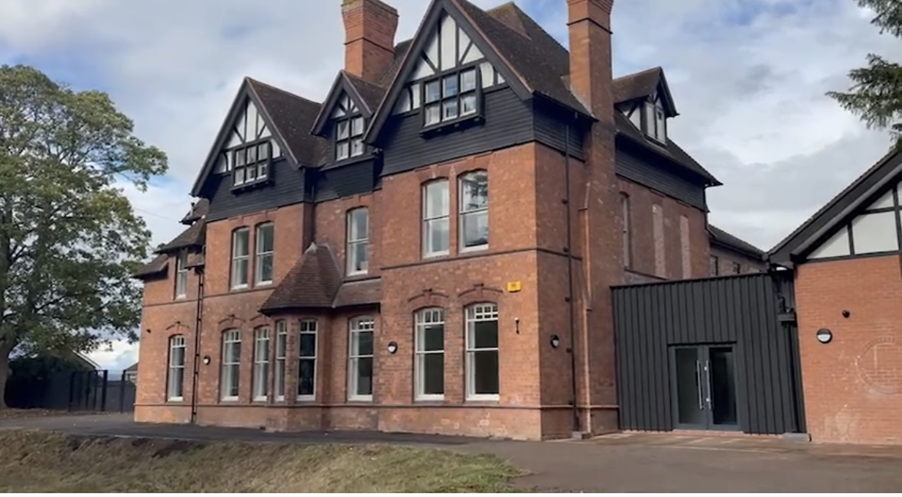
January 2026

Welcome Letter
Executive Headteacher: Sally Alexander MBE
Dear future Parent/Guardian/Carer,
This prospectus gathers the key information you will need throughout the academic year—from term dates and daily routines to our music‑specialist opportunities and safeguarding procedures.
Welcome to Kimichi School—a place where curiosity is celebrated, individuality is nurtured, and music infuses every corridor with energy. For more than a decade we have paired academic rigour with creative freedom, small classes with big ambitions, and an ethos of kindness with the courage to perform. Whether a student’s passion lies in physics, poetry or the power of a single note, our bespoke approach ensures they are known, supported and stretched every day. We invite you to step inside, feel the unmistakable Kimichi vibe and discover how extraordinary learning becomes when young people are allowed to be unmistakably themselves.

Our Ethos & Values
Kimichi School was founded on three guiding principles:
• Every pupil is known and valued.
• Music and the arts foster confidence, discipline and joy.
• Small classes and bespoke teaching unlock individual potential.
Wishing you a happy, healthy and safe start to the year,
Sally Alexander MBE
Headteacher
SPRING TERM
- 8th January – Term starts
- 16th – 21st February – Half Term (1 week)
- 24 February – 4 April (5 weeks)
- 27th March – End of Term
SUMMER TERM
- 20th April – Term starts
- 25th May – 29th May Half‑term
- 29th June – 3rd July Mid‑term Break
- 29th July – End of Term

THE SCHOOL DAY
9.45am – Registration
10am – Lesson 1
10.45am – Lesson 2
11.30 – Break
12.00 – Lesson 3
12.50 – Lesson 4
13.35 – LUNCH
14.30 – Afternoon Registration
14.35 – Lesson 5
15.25 – Lesson 6
16.15 – Whole school clean-up
16.30 – School ends

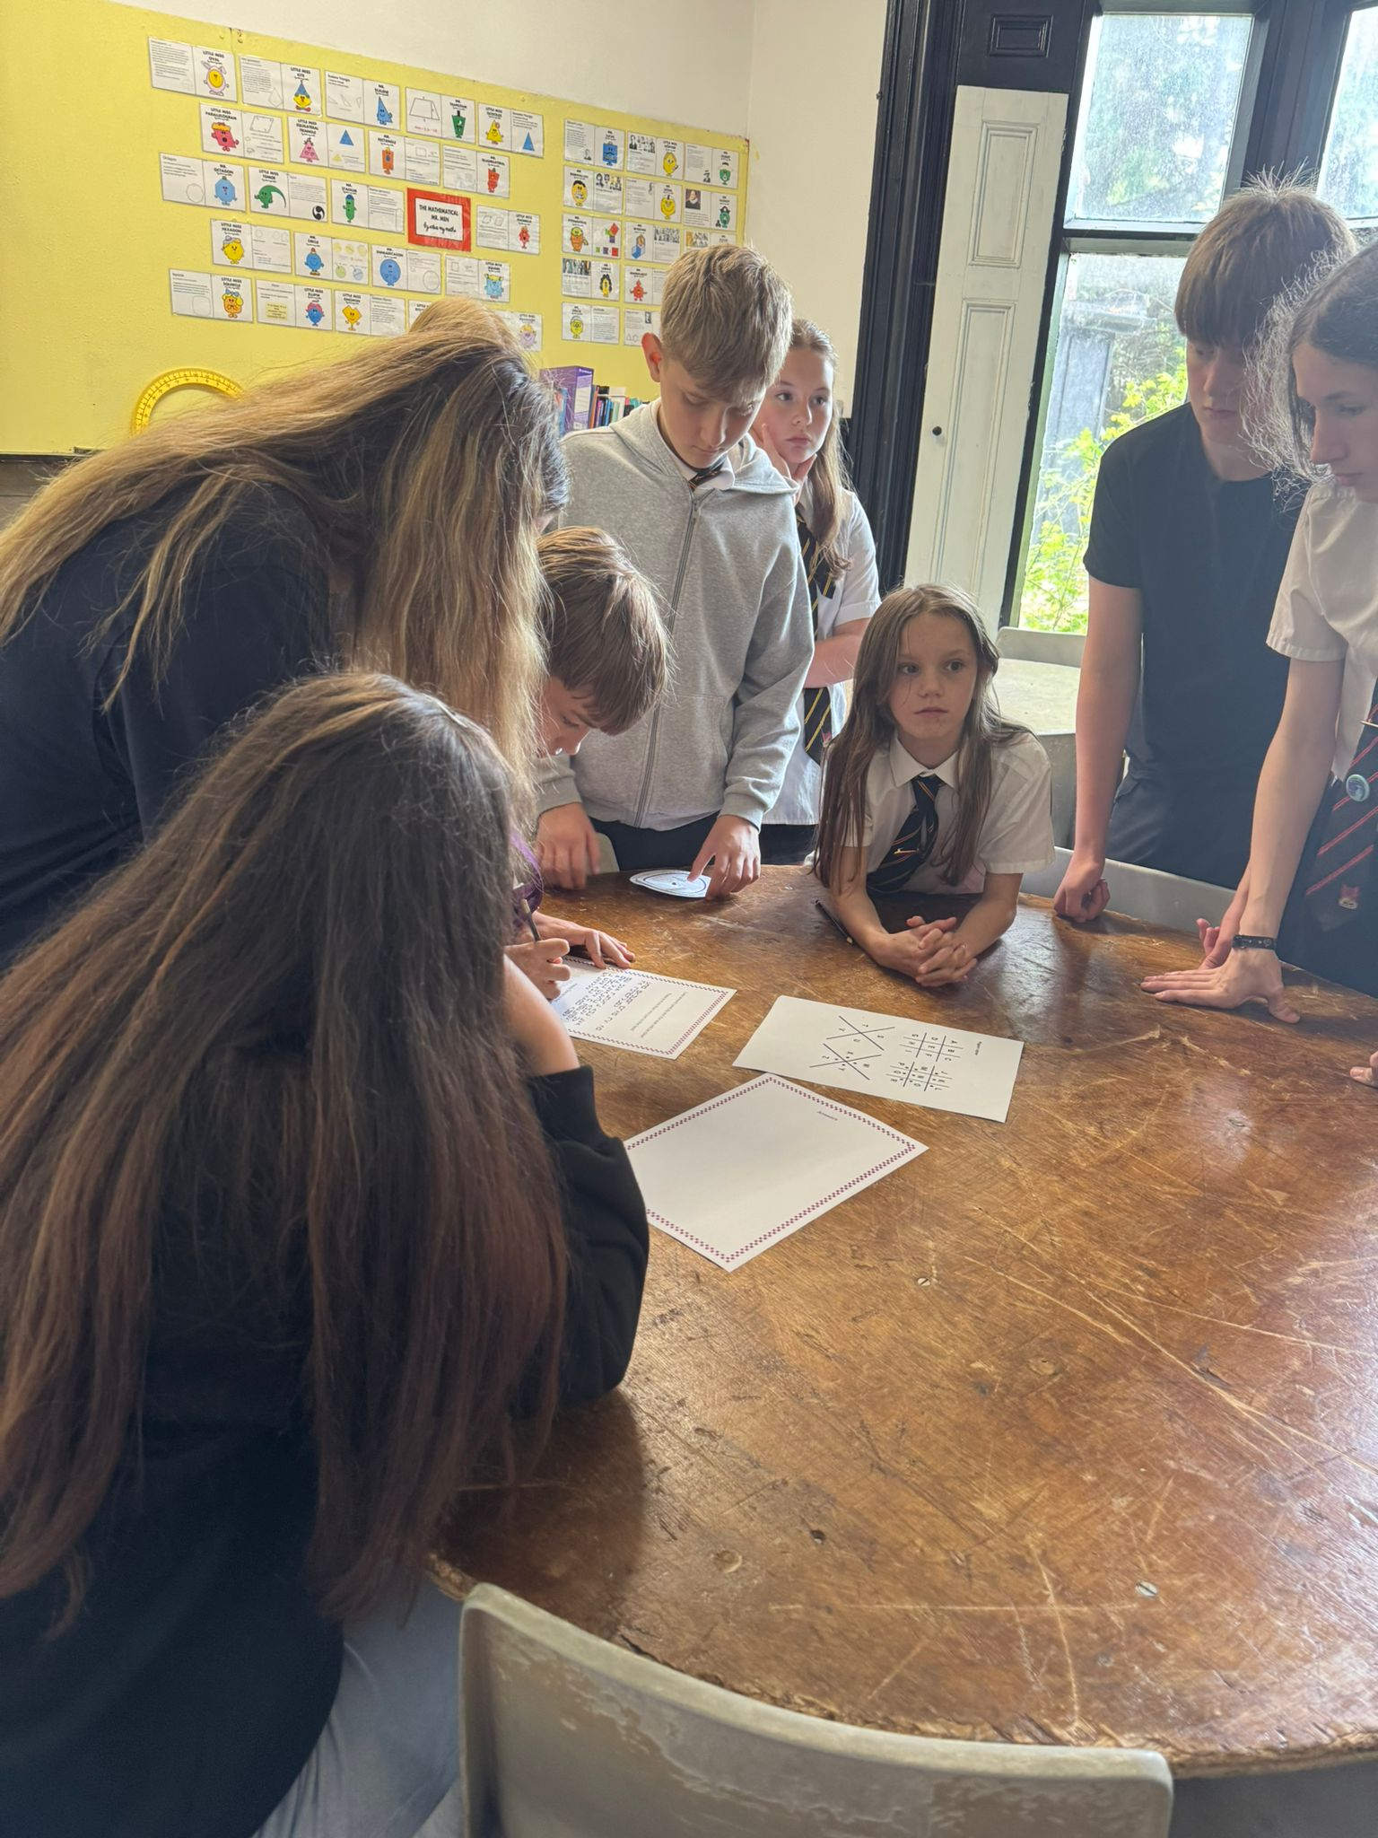
Curriculum & Year Groups
• Lower School 1 – Year 7
• Lower School 2 – Year 8
• Inters – Year 9
• Lower Seniors – Year 10
• Upper Seniors – Year 11
GCSE courses commence in Year 9, with examinations in Year 11.
We are delighted to offer our Explorers Programme for those who need a little extra support: Kimichi’s tailored pathway for pupils who learn best through practical, skills-based projects rather than the formal GCSE route, while still offering a valuable enrichment option for some older students. Half-term topics on a broad theme—anything from natural disasters to self in the community—which then threads skills from English, maths, science, the humanities and the arts into practical, enquiry-driven tasks. Because lessons are framed as real-world investigations, students develop strong critical-thinking and research habits alongside the vocabulary and concepts they will later need for potential GCSE study. Explorers also emphasises collaboration and presentation: pupils plan fieldwork, debate solutions, create displays and compile their achievements to evidence both academic progress and “soft” attributes such as teamwork, resilience and leadership.

Fees & Bursaries
We ask that fees are paid termly and up front unless a payment plan has previously been arranged and agreed with the school.

Bursaries: support paired with responsibility
Kimichi is proud to offer a limited number of means-tested bursaries, awarded strictly on a case-by-case basis after a full financial assessment. Because every bursary place is funded directly from the school’s own budget, each award represents a significant commitment of resources that would otherwise be available for whole-school projects. For that reason, families who accept a bursary also accept a clear obligation: pupils must play an active, reliable role in the wider life of the school. Attendance at concerts, open days, rehearsals, fund-raisers and other extracurricular commitments is not an optional “extra”—it is the way bursary holders give tangible value back to the community that supports them. We therefore ask parents to prioritise these dates, ensure punctual attendance, and reinforce with their children the importance of honouring this agreement. Consistent participation safeguards the sustainability of the bursary scheme and allows us to continue extending opportunity to future Kimichi families.

School Day & Attendance
Opening times:
School site opens at 8am and registration is at 9.45am. Please let us know if your child is going to be late via email/phone (see below) or unable to attend as soon as possible. The school day finishes at 4.30pm and the building will be shut from 5pm.
Please ensure pupils are on time for the start of the day. We understand the vagaries of the public’s transport system, but our late start compensates for this, so we do expect all pupils to be on time.

DfE continue their attendance drive this year and “do not consider a need or a desire for a holiday or other absence for the purpose of leisure and recreation to be an exceptional circumstance.” If your child is going to be absent for any reason, we expect permission to be asked and notification for every day of absence via hello@kimichiworcester.co.uk.

Last pick up time:
There will be staff on site until 5pm every day, but we do ask that parents make sure their child is picked up by then, unless by prior arrangement. Many of the children make their own way home and are welcome to stay until 5pm if they wish. Obviously, if we have an after-school event that will not apply.
The exception to this is on Fridays when school finishes at 3.45pm, not 4.30pm.

Uniform
Uniform Standards — Academic Year 2025 / 26
Kimichi School maintains a smart-but-simple dress code designed to foster pride, equality and readiness for learning. Unless specific sensory adaptations have been authorised by the Head Teacher or Deputy Head, the following requirements apply to every pupil:
Item | Specification
Main attire | PLAIN, SMART AND DARK: black or dark grey trousers / skirt. No jeans allowed.
Shirt / blouse | White, black or dark grey, long- or short-sleeved, worn tucked in.
House tie | To be worn daily and fully fastened unless sensory issues have been disclosed and other arrangements agreed by the school:  •Enigma House – Burgundy  •Richardson House – Light Blue  •Othello House – Dark Blue  •Knight House – Dark Green
Outer layer | Plain dark blazer or plain dark hoodie (school crest optional). No branding, patterns or images.
Footwear | Black, shoes; discreet laces. Smart trainers are permitted.
P.E. kit | Plain dark sports top and shorts / tracksuit bottoms; change of socks; supportive trainers. Kit must be brought on the day P.E. is timetabled and pupils must change into and out of it before and after the lesson.
Please note
- Logos, slogans, stripes, checks and other decorative patterns are not permitted on any garment, including hoodies and sportswear.
- The school reserves the right to determine whether an item meets the “plain, smart, dark” criterion; pupils may be asked to replace non-compliant clothing.
- Repeated failure to wear correct uniform—or to bring appropriate P.E. kit—will be dealt with under the behaviour policy.
By adhering to these guidelines, students represent both themselves and the School with dignity and professionalism. We appreciate parents’ full support in maintaining the high standards that distinguish Kimichi School.
Lunch Arrangements
Packed-lunch provision
Kimichi Worcester does not currently operate an on-site catering service; pupils are therefore required to bring a nutritious packed lunch each day. Kindly ensure that all food is clearly labelled and nut-free in consideration of allergies within the community.
Local refreshments (optional)
With parental consent (see General Permission Form), pupils may purchase refreshments from the parade of shops a ten minute walk from the school during break or lunch. The following conditions apply:
- Minimum group size: pupils must leave the premises in groups of three or more.
- Registration: they must sign out before leaving and sign back in immediately on their return.
- Timekeeping: the lunch bell signifies the end of the break; late returners will be recorded and followed up.
Our neighbours have been supportive of Kimichi, and we wish to maintain this excellent relationship by ensuring exemplary behaviour and prompt payment at all times.
Thank you for helping us keep lunchtimes safe, orderly and pleasant for everyone.
Equipment Requirements
Students will be expected to provide their own equipment for lessons. It is unacceptable that some of the (particularly upper school) members of the school come to school without anything at all and expect staff to provide all their equipment. It is naturally expected students will be well-equipped for all lessons.
Specific lesson equipment includes (not an exhaustive list):
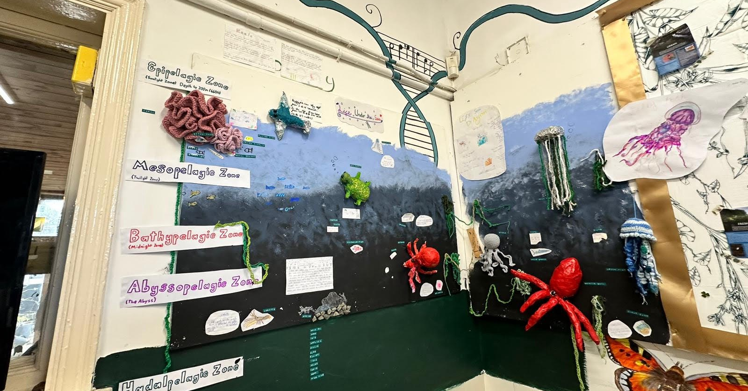
GENERAL
- Pens
- Pencils
- Pencil sharpener
- Eraser

MATHS
- Ruler – 15cm minimum and preferably clear
- Protractor (360° or 180°)
- Pair of compasses
- Scientific calculator
- Eraser

For BIOLOGY, please see above plus
- Colouring pencils
- 30cm ruler

Essential Equipment
Every student is expected to arrive each day with a fully stocked pencil case containing the standard items named above. Pupils who come to lessons without the required tools will now be directed immediately to the on-site equipment shop and charged for replacements; the current price list will be displayed on the Pupil board.


Planners:
We can provide a folder for each child if they would rather keep any worksheets together; alternately worksheets will be stuck in their exercise books immediately. We have planners that they should keep information in, eg. homework. These only work if they bring them to school and keep them filled in, and if you also ask to see them at home. If they lose them, there will be a £5 replacement cost. Do please check school bags for these; teachers always spend some time at the end of a lesson ensuring that homework is filled in by everybody in the class if given.

PE:
Your child will continue to have PE lessons and will be expected to bring appropriate PE kit (sportswear) on their prescribed day according to their timetable; (Quavers – Inters on Monday and Lower/Upper Seniors on Wednesday) This includes trainers – school shoes will not be accepted. There is space to change, and it is not pleasant for them to remain in sweaty clothes throughout the day. We have secured football training at a local sports centre. PE is a statutory lesson, so all pupils are expected to participate.

Storage & Security
Each pupil will be assigned a personal locker—and, where necessary, an additional bag space—for the safe keeping of books, instruments, PE kit and other belongings. Bags should be deposited in this area at the start of the day and not carried from lesson to lesson; doing so reduces clutter, trip hazards and wear on valuable equipment.
Please note that the school cannot accept responsibility for money, electronics or other valuables left on site, and items are stored at the owner’s risk. In line with statutory guidance, the school reserves the legal right to inspect lockers, bags or other possessions (with due notice and in the presence of a senior member of staff) should safeguarding or discipline concerns arise. Cameras may be used to monitor communal storage areas for security and safety.

Electronic Devices
Mobile phones, tablets etc. are not to be used throughout the school day and must be placed into the boxes allocated to each year group. If anyone wants to or needs to use their phone they are welcome to, but they must ask a member of staff. We ask that children log onto the school Student network WIFI to ensure online safety and not use data so we can be sure that they are safe online. Please also be aware that we cannot assume responsibility for personal electronic items. Laptops are available for use by students at any time in lessons or DSAW’s if wanted/needed.

Music Tuition
Full time, fee paying children will be allocated up to two private lessons per week. If more are needed, these can be arranged for an extra cost. For those that flexi-school, a charge of £50 + VAT per term, per instrument will be added to the fees.

Music at Kimichi
All pupils learn at least one instrument and join an ensemble.
Weekly schedule:
- Monday - Orchestral Ensembles
- Wednesday - Chamber Groups
- Thursday - Choir
- Daily/ad hoc – band, a cappella and wind band rehearsals
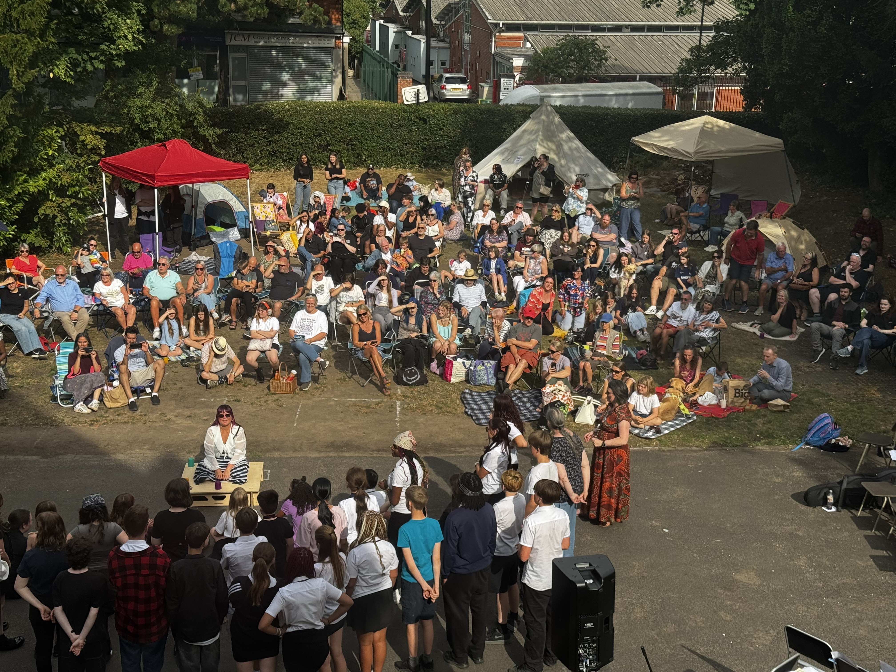
KimichiFest in Birmingham.

Pastoral Care & Wellbeing

Pastoral support is the golden thread that runs through every lesson, rehearsal and break‑time at Kimichi. Our day starts and ends with informal check‑ins so staff can spot worries early, and each pupil has a named tutor who remains their first point of contact throughout their time here. Because classes are small, teachers know pupils’ triggers, learning profiles and family contexts in depth; this allows us to tailor swift, discreet interventions—whether that is a one‑to‑one “reset” chat, a guided mindfulness break, or a short series of music‑therapy sessions run by our in‑house specialists. Weekly “Explorers” projects extend that care further, giving pupils structured time to develop self‑awareness, social communication and independence in a low‑pressure setting.

Our approach was singled out by Ofsted, who noted that pupils “feel safe and well looked after” and “trust adults to help them” ([kimichischool.co.uk]). We maintain that trust through:

Open‑door communication – parents are always welcome to call or pop in to have an informal or formal chat about their child’s progress or with any questions or concerns they may have

Specialist interventions – delivered by staff in-house

Peer culture – restorative discipline, a proactive School Council and mixed‑age unstructured time promote empathy, leadership and mutual respect.

Safe spaces– the Den and the garden offer calm retreats for pupils who need a sensory break before re‑joining lessons.

The result is a community where emotional growth is valued as highly as academic progress, and where every child—whether they are following the full GCSE pathway or our experiential Explorers programme—feels known, supported and ready to thrive.


Communication Channels
Contact details:
Phone no: 0751 565 4793
Enquiries: hello@kimichiworcester.co.uk

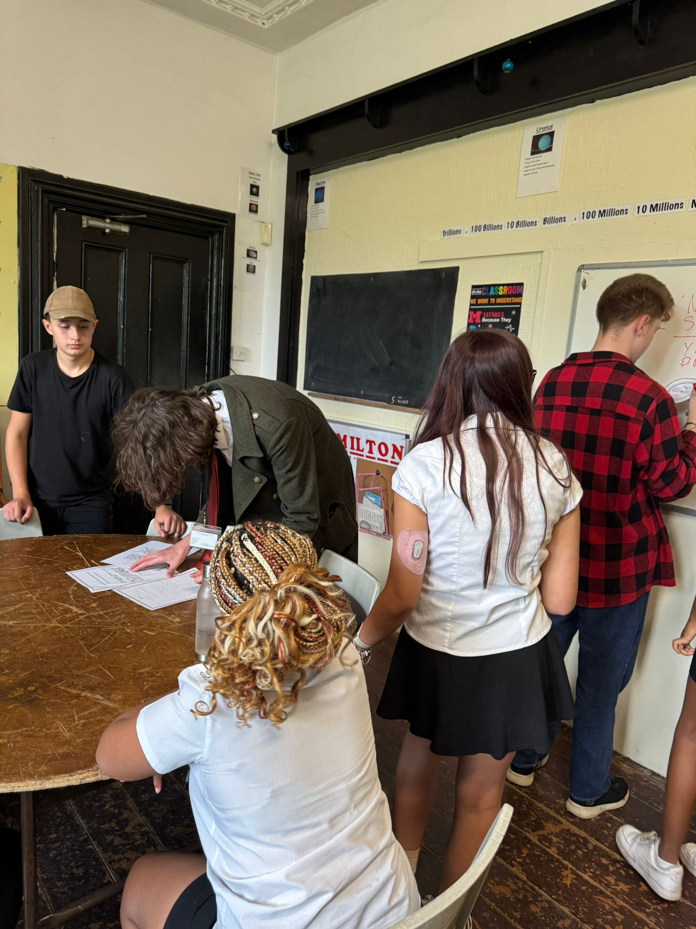
Clubs & Enrichment
Life at Kimichi extends well beyond the timetable.
Arts & Culture – regular trips to theatre productions, Birmingham Symphony Hall concerts, and recitals at the Conservatoire; ticket prices are kept to a minimum and transport is organised by staff so everyone can experience world‑class performance.
Student‑led societies – if a hobby isn’t on the list, pupils are encouraged to create it. Recent start‑ups include Dungeons & Dragons, Manga Art club and Debate Club. We provide the room, the supervision and a small budget; the ideas come from the children.
Active bodies, active minds – Among Us live, cricket at lunchtime, and a relaunched Dance Club that will work towards local festival entries.
Service & enterprise – houses tend their allotments, pupils make and sell produce at the winter fair and pupils perform in care‑homes.

Whether a child dreams of leading a jazz combo, coding a game or planting a pollinator garden, we’ll help them find—or found—the club that makes Monday mornings exciting.

Transport & Parking
For everyone’s safety we operate a restricted-access policy on the school drive. Pupils often use the front forecourt for outdoor learning or recreation, and vehicles manoeuvring at speed pose an obvious risk.
- Drop-off / collection: unless you hold a blue badge or have pre-arranged authorisation, please set your child down on the side street and allow them to walk the short drive.
- No vehicular access during the school day: between 09:00 and 16:45 the gates remain closed to parent traffic. If you must collect a pupil for an appointment, park on the road and report to the front door; a member of staff will escort your child out.
- Authorised drivers: staff, deliveries and approved taxis may enter at no more than 5 mph.
- After-hours events: limited on-site parking is opened for concerts and meetings; stewards will direct cars. We strongly encourage lift-sharing or public transport whenever possible.
Thank you for helping us keep the entrance clear and the playground safe.

Safeguarding & Well-Being
At Kimichi School, safeguarding is not a checklist—it is the cornerstone of everything we do. We recognise our full statutory duties under Keeping Children Safe in Education (DfE, 2025), the Independent School Standards and relevant Ofsted guidance, and we treat every recommendation as imperative.
- Rigorous Training & Induction
Every member of staff and every visiting tutor completes enhanced vetting and a thorough induction. Annual update training and termly refreshers ensure that practice always reflects the latest national guidance.
- “Actively Bothered” Culture
Rather than relying on hyper-vigilance alone, we promote an actively bothered mind-set: staff are expected to notice, to ask, and to act. Daily well-being check-ins, open-door pastoral offices and rapid referral pathways mean concerns are addressed swiftly and sympathetically.
- Transparent Policies
Our Safeguarding, Anti-Bullying, Online Safety and related policies are reviewed at least annually and may be requested from the school office or downloaded from our website.
- External Validation
We welcome ongoing scrutiny—from regulators, governors, parents and learners themselves. Consistently positive reviews frequently highlight our caring environment, swift communication with families and the quality of pastoral support. We view this feedback as an important external barometer and act on it to strengthen practice further.
Should you have any questions or require copies of specific policies, please contact the Designated Safeguarding Lead via hello@kimichiworcester.co.uk or speak to the school office. Protecting your child’s welfare—and that of every member of our community—remains our highest priority.

